Due in the appropriate D2L Dropbox, at the time announced in class. A Word File contining this document will be loaded on D2L by the end of the day on Friday.

You will upload this document with signatures and answers, and PDF files of any supporting documents you wish me to consider when giving partial credit for wrong answers.

Test Rules

By placing my signature on the line below, I am stating that the materials turned in as my solution to this test are my own independent work. I did not discuss the contents of this test with any other human being (except possibly Dr. Delahoussaye). I did not copy anyone else's work and did not give or request assistance from anyone else on any topic related to this class in general, or this test specifically.

If I have violated the above requirements, I will write the words "rules violated" on the signature line, next to my signature. In doing so I will be stating that I violated the exam rules and I understand that I will receive a reduced grade for exam because of the violation, and possibly receive a grade of ZERO.

I understand that if I am found by the instructor to have violated the rules of the exam and have not admitted it on this page, then I will receive a grade of ZERO on this exam.

Sign your name here :Alexandre Baillargeon

Please place an X near the statement that is most nearly true:

x I observed NO violations by other students of the test rules stated above.
I observed approximately violations by other students of the test rules stated above.

You will NOT be asked to explain your answer to the above question.
Note: you must write your final answer in the space provided on these page!

Problem 1 (20 points).

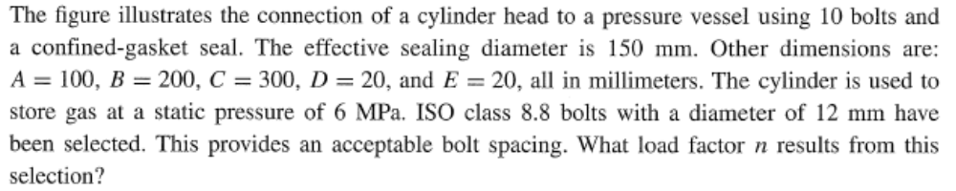

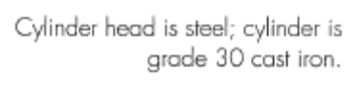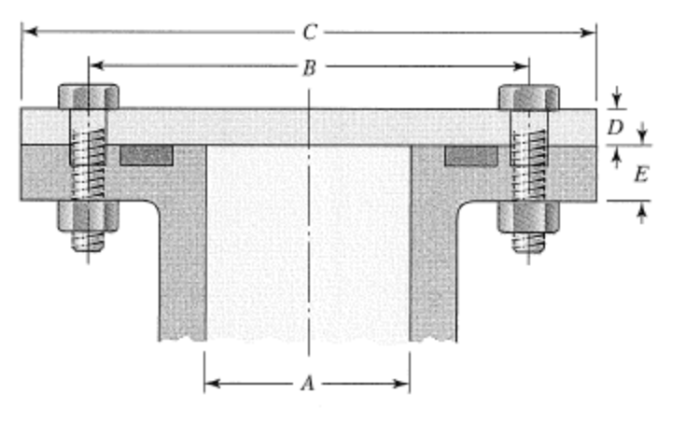

  - Determine the maximum cylinder pressurethat will allow a load factor of safety of safety of 1.0 during Hydrostatic testing.

Your answer is: 27.88 MPa

  - Determine the maximum cylinder pressure that will allow a load factor of safety of 1.5 in fatigue. Assume that the pressure fluctuates between the maximum pressure and 0 psig.

Your answer is: 12.67 MPa

Problem 2 (20 points).

If the load in the figure below is doubled, what size bolts should be used to provide a factor of safety of 2.0, considering the bolts only.

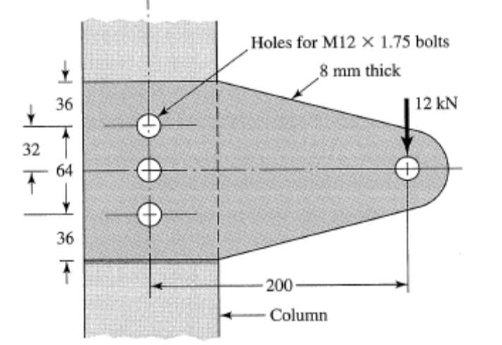

Your answer is: 17.88mm (Next size up) → 20mm

Problem 3 (20 points)

Use the figure given below, but the load is not static but varies between a minimum load of ZERO and maximum load of 5000 lbf. Presume that the weld leg sizes are not yet known. Find the minimum weld leg size that would provide a minimum factor of safety of 2.0 against static and fatigue failures. Use a #60 electrode.

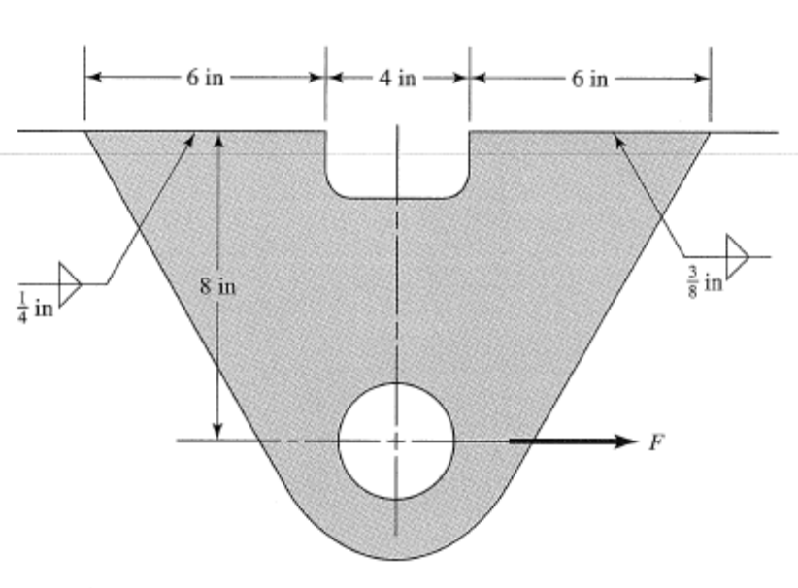

Your answer is: 3/16”. Used tbl 9-3 and 9-6 for allowable shear. Fatigue stress concentration factor of 2.0(Tbl 9-5)

Problem 4 (20 points)

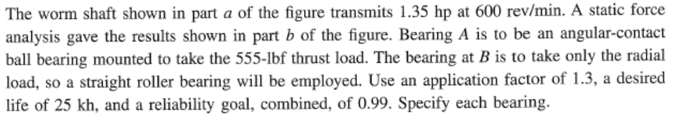
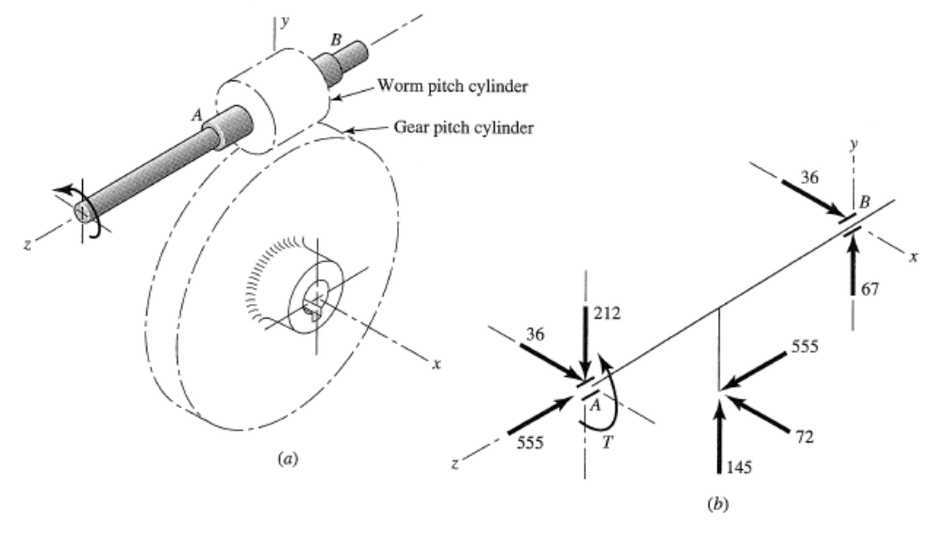

Your answer is: Bearing A – 02-95 / Bearing B – 02-25

Bearing A (C0: 85000.00) Catalog Load: 112815.33 < 121 kN
Bearing B (C0: 8800.00) Catalog Load: 5334.18 < 16.8 kN

Problem 5 (20 points)

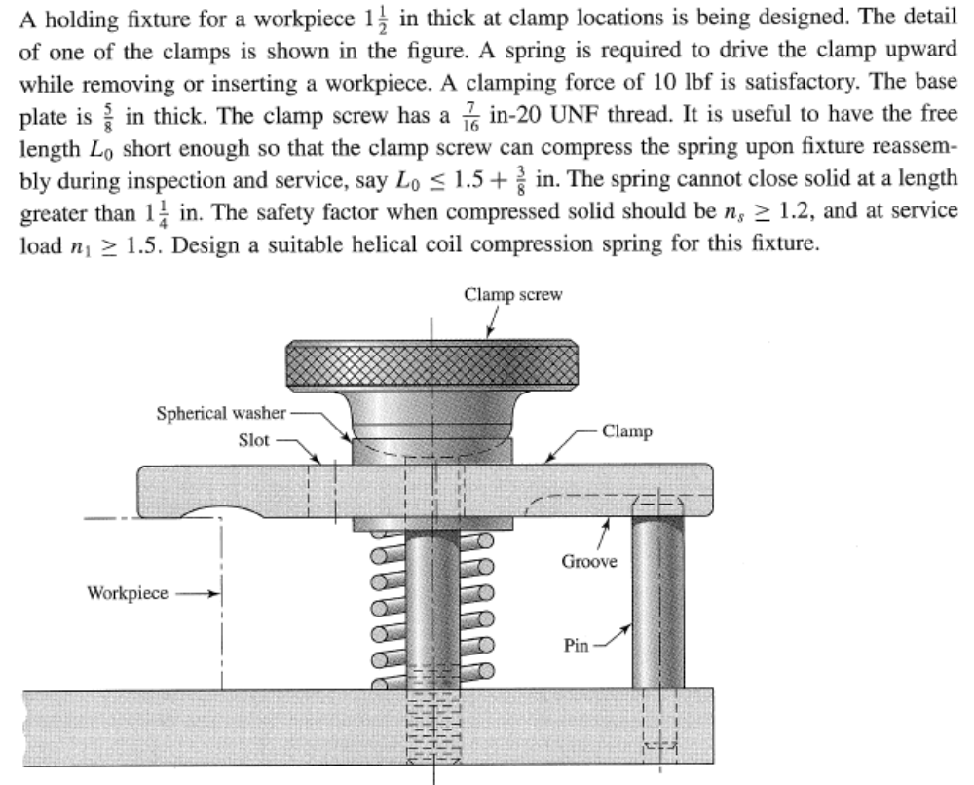

Note, Use Music Wire, with ends squared and ground. Use the cheapest possible spring.

Your answers are: d = __0.080”_____________________

D = __0.5675”____________________

Pitch = _0.139”_____________________

Free Length = __1.875”____________________

Solid Height = __1.147”____________________

Total Turns = ___14.3___________________

